**CB[1] – Enrichment – Latin Square Design**

Part I – Individual Quiz (Before Class)

Part II – Group Quiz (During Class)

1. What are the structural features of a Latin Square Design (2 pts)?

2 nuisance factors and one factor of interest.

Number of levels is the same for all three of these factors.

Every pair of factors is crossed, for each choice of two factors, each combination of levels of the wo factors occurs exactly once.

1. What are common situations where a Latin Square Design is useful (2 pts)?

Subjects exhibit a lot of variability

The order of the conditions has a systematic effect

The factor of interest is experimental.

1. How do you calculate the Estimated effect and degrees of freedom for the Row factor for a Latin Square Design (2 pts)?

• Degrees of freedom (df): (Treatment df) = (Row df) = (Column df) = p – 1

Estimated effect = Obs- fit

**End of Part I**

1. Were you in class on time (2 pts)?

YES

1. Get an ANOVA table using for the Fuel Efficiencies data and evaluate the results. Also, check the requirements of the residuals being normally distributed as well as the variances being equal. (8 pts).

Analysis of Variance Table

Response: mpg

Df Sum Sq Mean Sq F value Pr(>F)

driver 3 5.90 1.966 0.4954 0.69869

model 3 736.91 245.637 61.9026 6.627e-05 ***

blend 3 108.98 36.327 9.1548 0.01173 *

Residuals 6 23.81 3.968

---

Signif. codes: 0 ‘***’ 0.001 ‘**’ 0.01 ‘*’ 0.05 ‘.’ 0.1 ‘ ’ 1

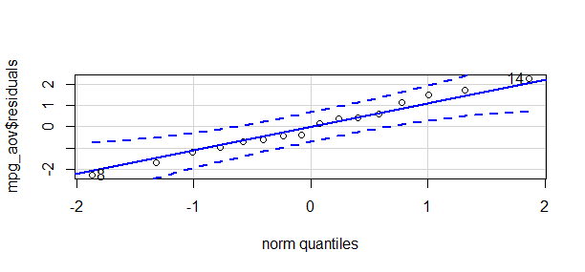

Levene's Test for Homogeneity of Variance (center = median)

Df F value Pr(>F)

group 3 0.0831 0.968

12